TITLE: - BRANCHING EXCERCISE

AIM: - To perform Branching Exercise in Git
DESCRIPTION:
Make a new folder called Patronus
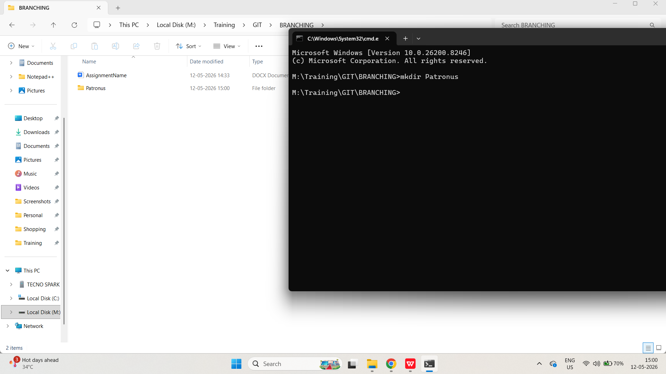
Make a new git repo inside the folder (make sure you're not in an existing repo)

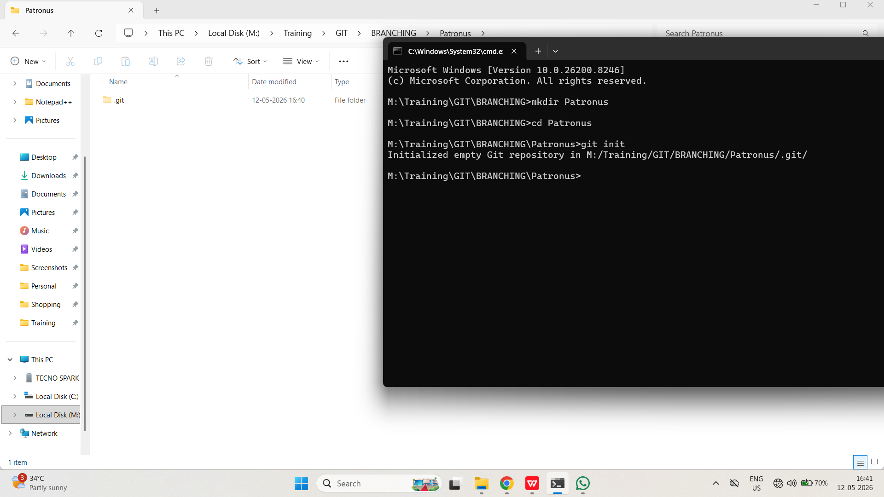
Create a new file called patronus.txt (leave it empty for now)

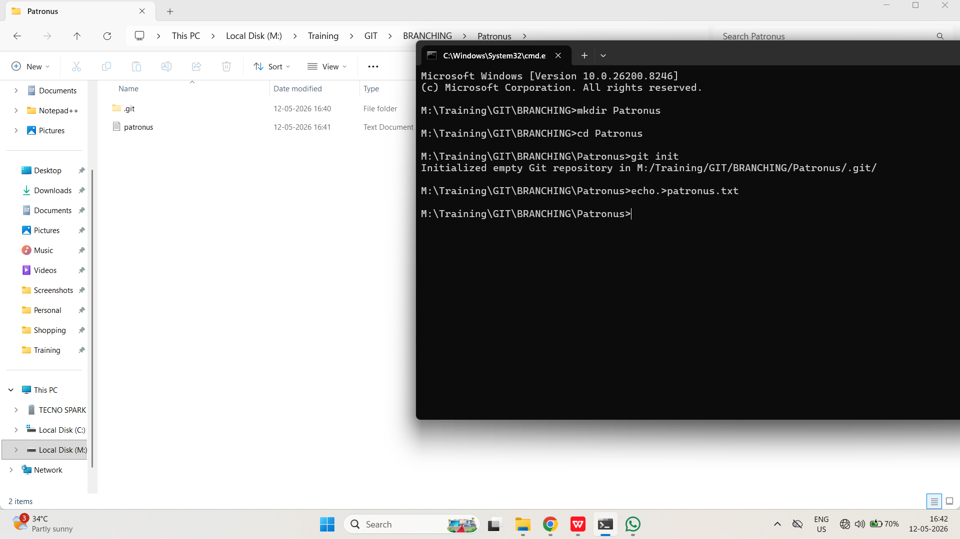
Add and commit the empty file, with the message "add empty patronus file"

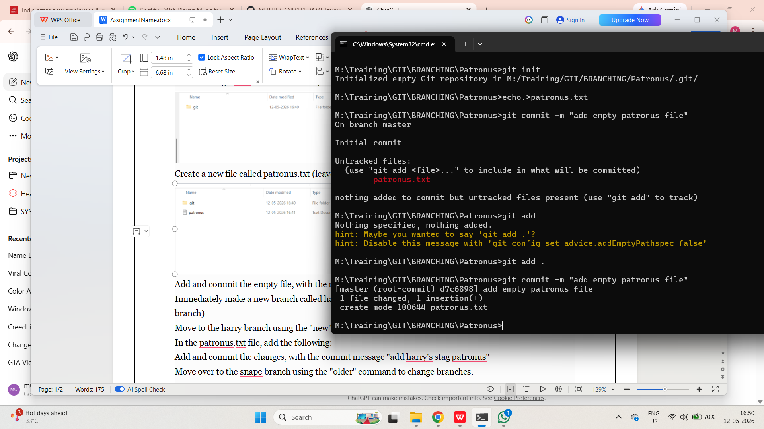
Immediately make a new branch called harry and another branch called snape (both based on the master branch)
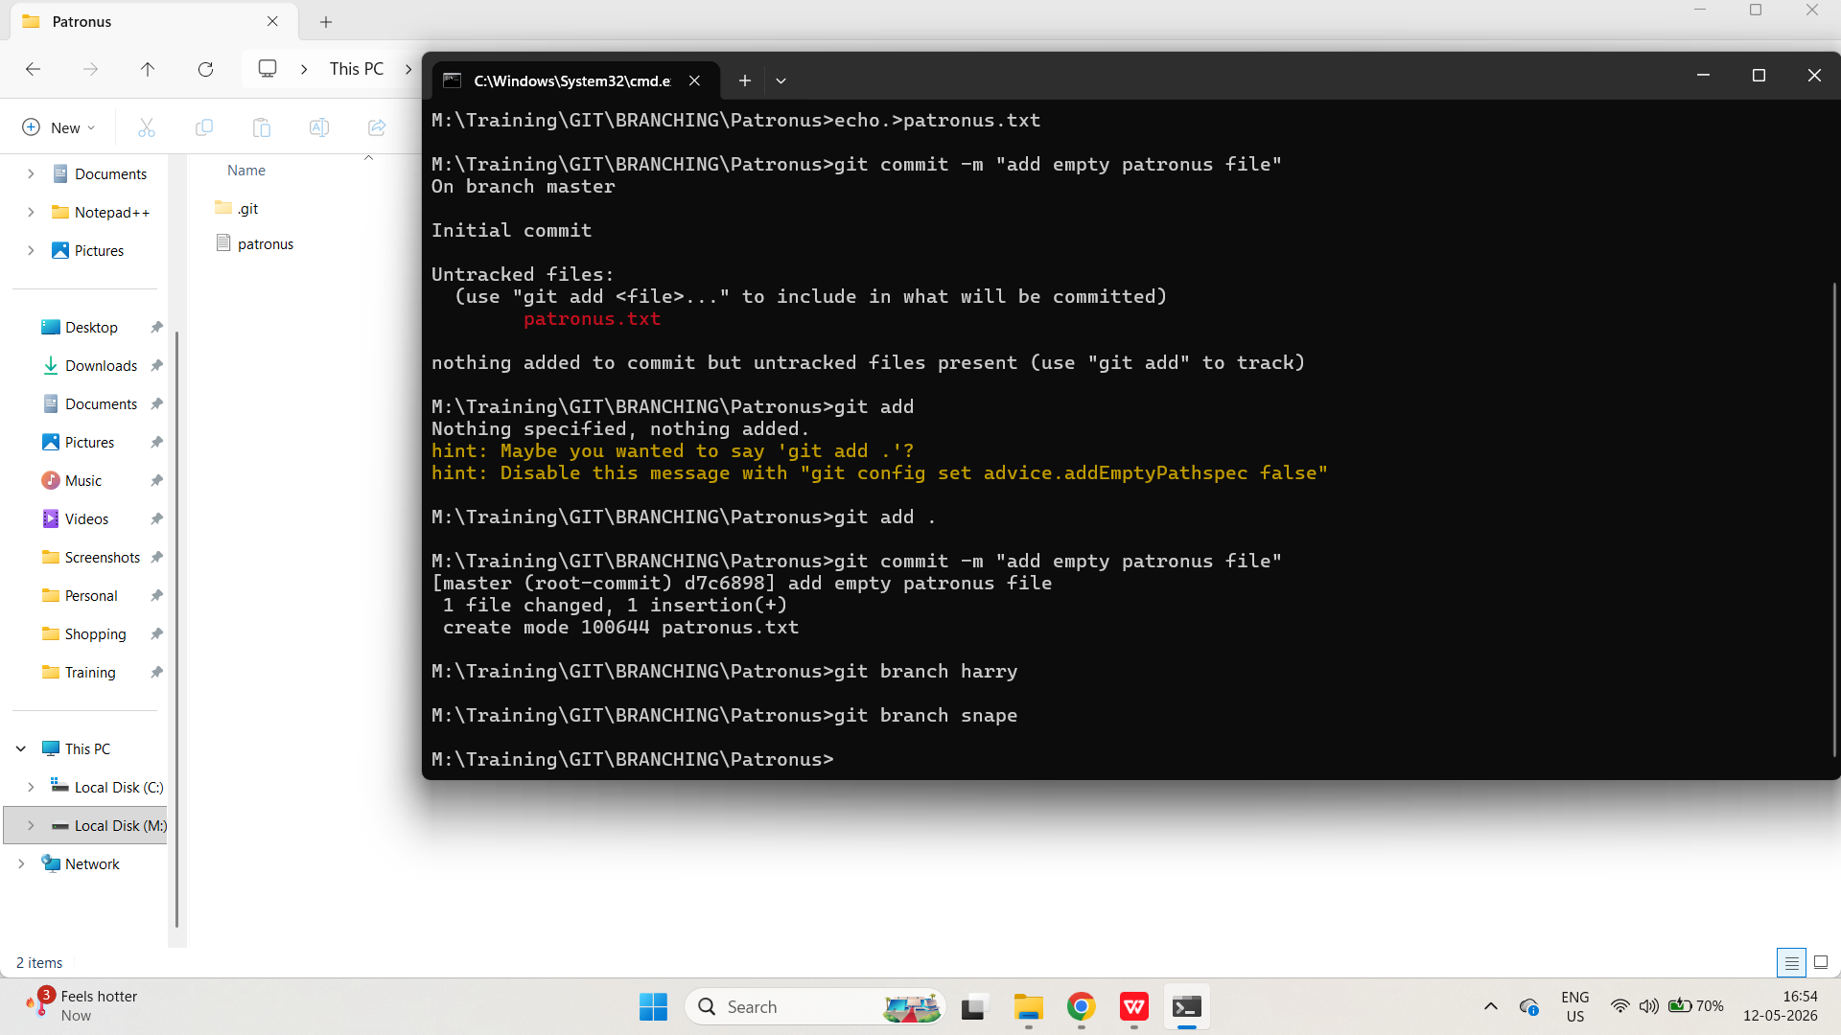

Move to the harry branch using the "new" command to change branches.
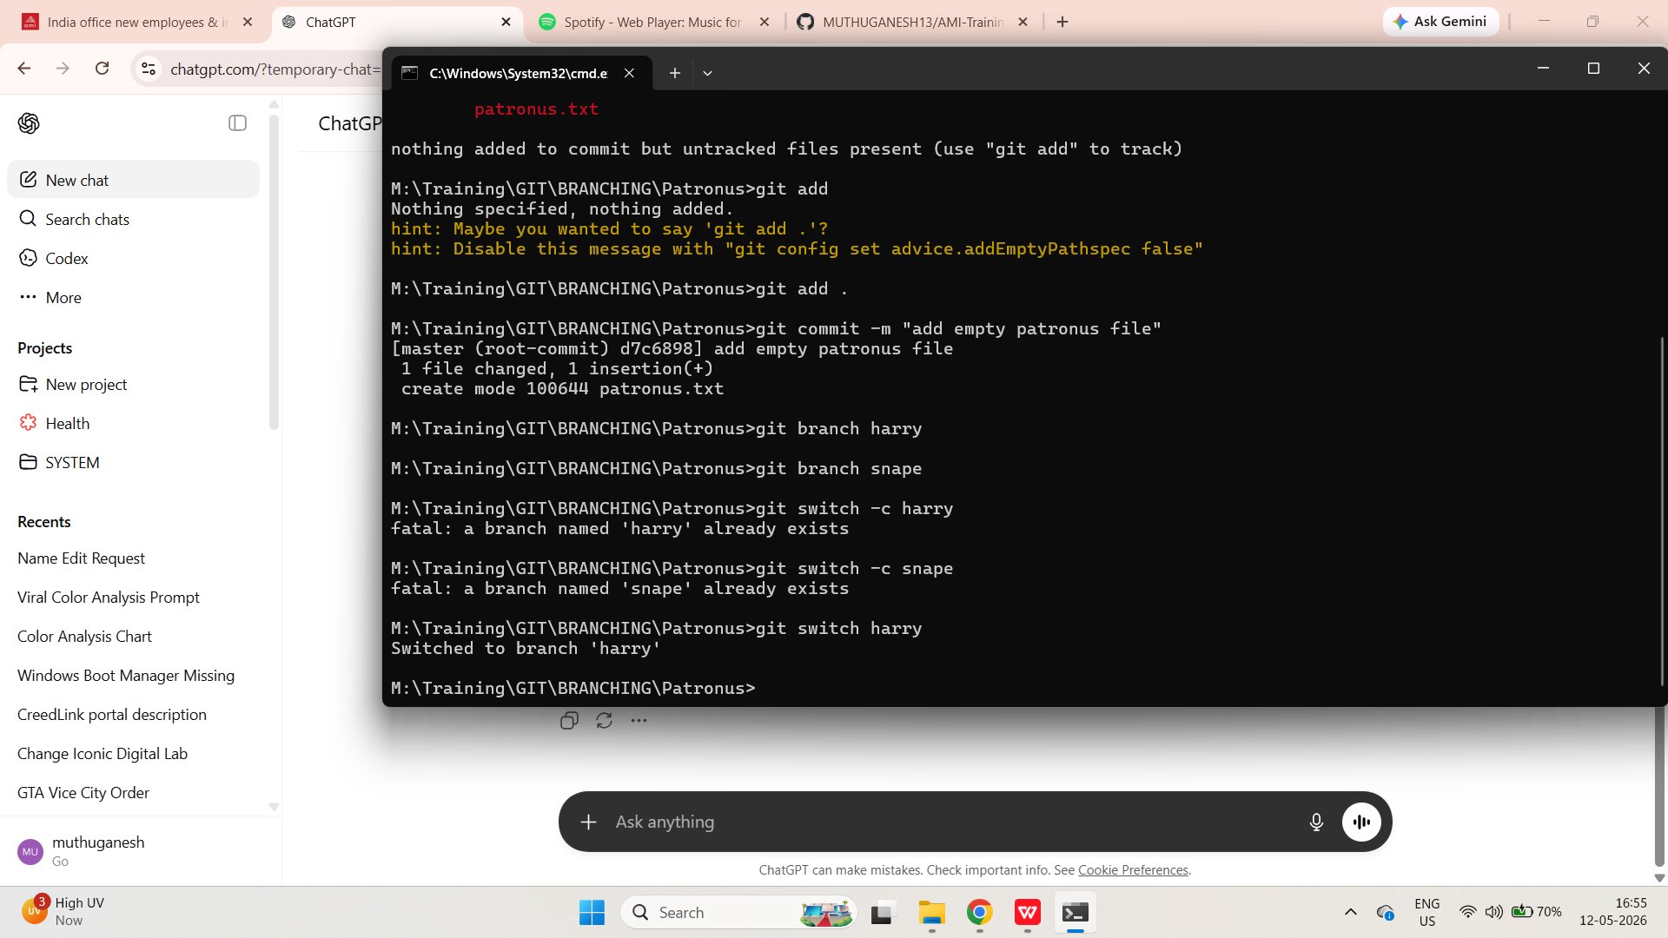

In the patronus.txt file, add the following:
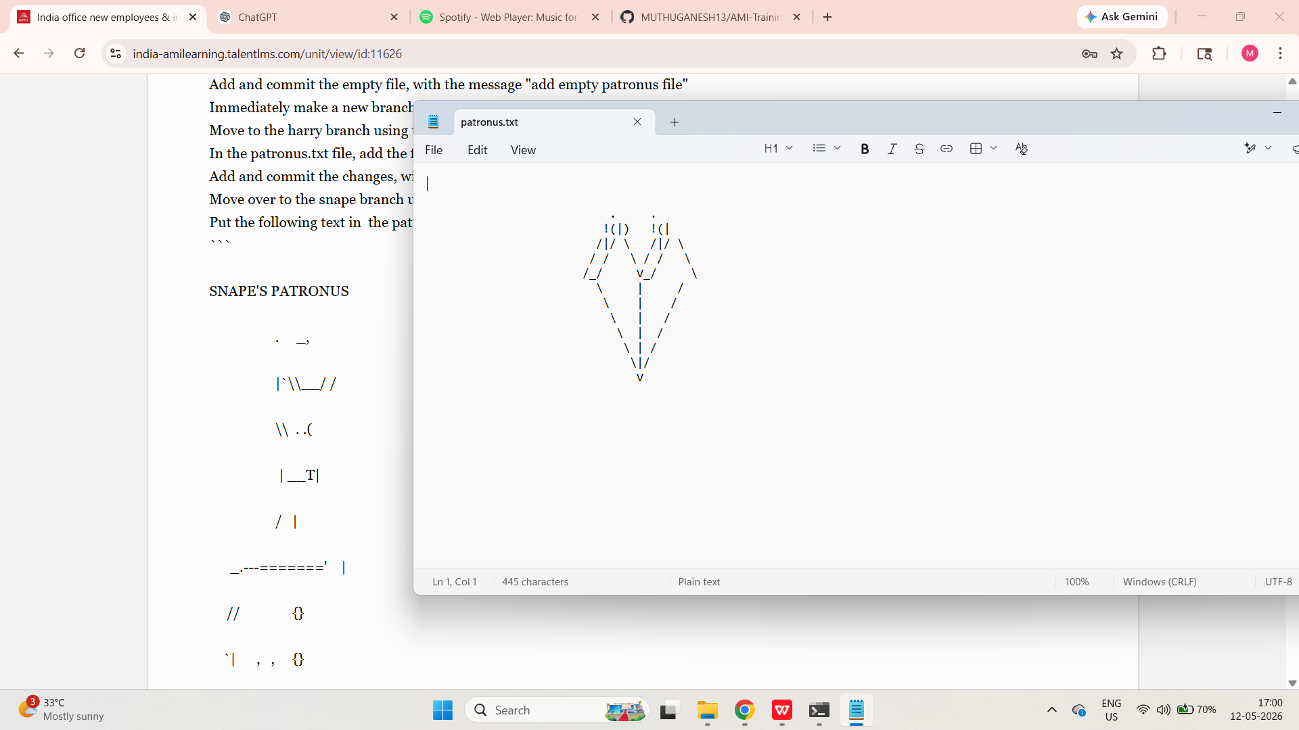

Add and commit the changes, with the commit message "add harry's stag patronus"
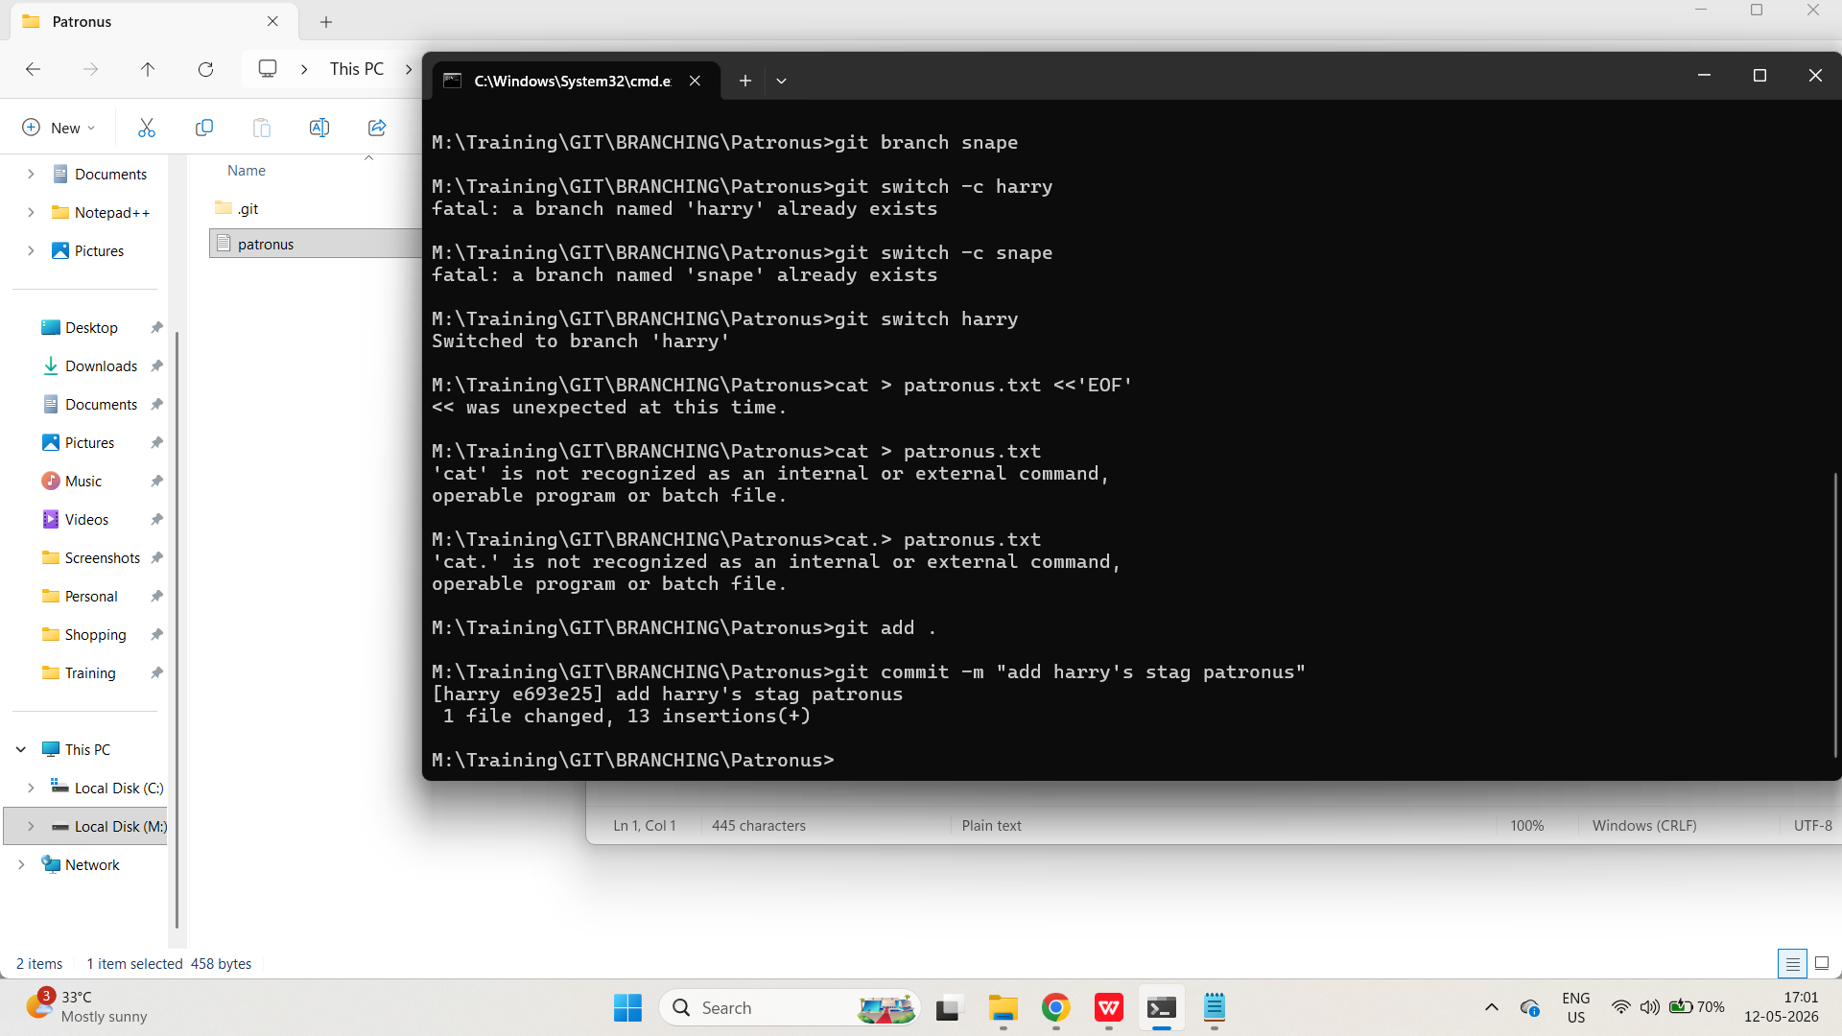
Move over to the snape branch using the "older" command to change branches.
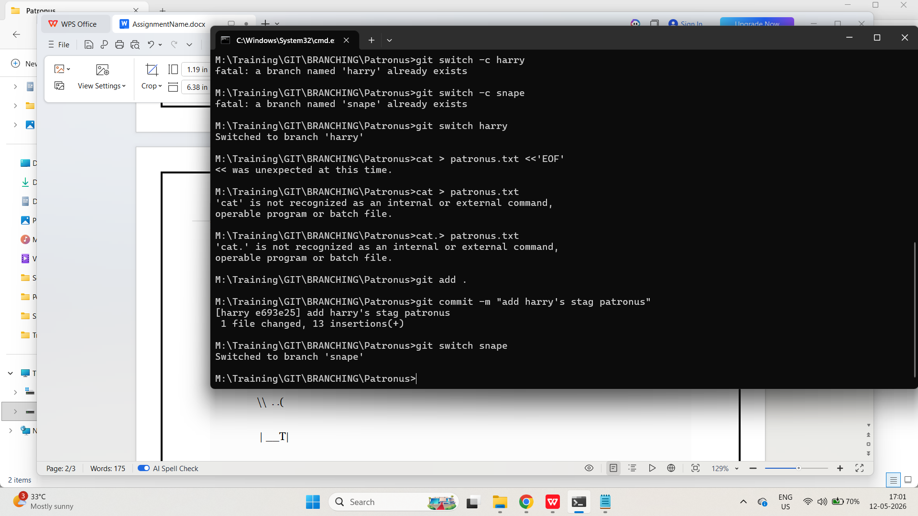
Put the following text in the patronus.txt file:
```
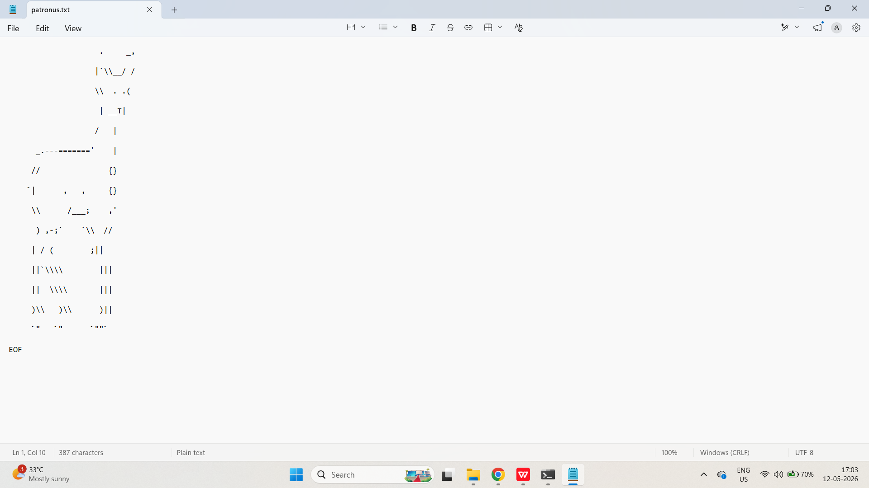

Add and commit the changes on the snape branch with the commit message "add snape's doe patronus"
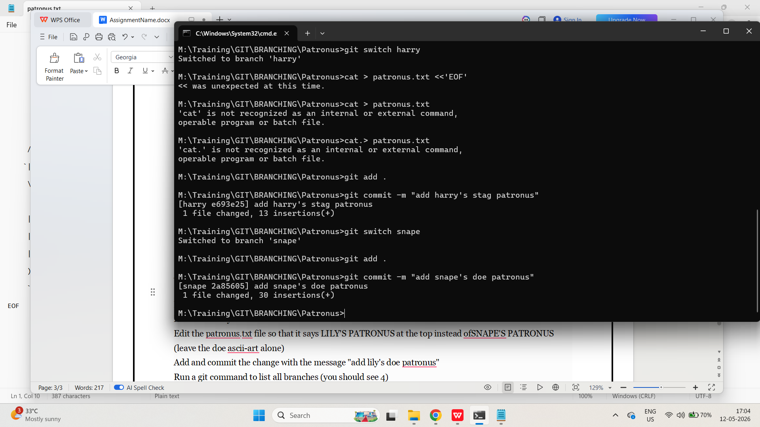
Next, create a new branch based upon the snape branch called lily
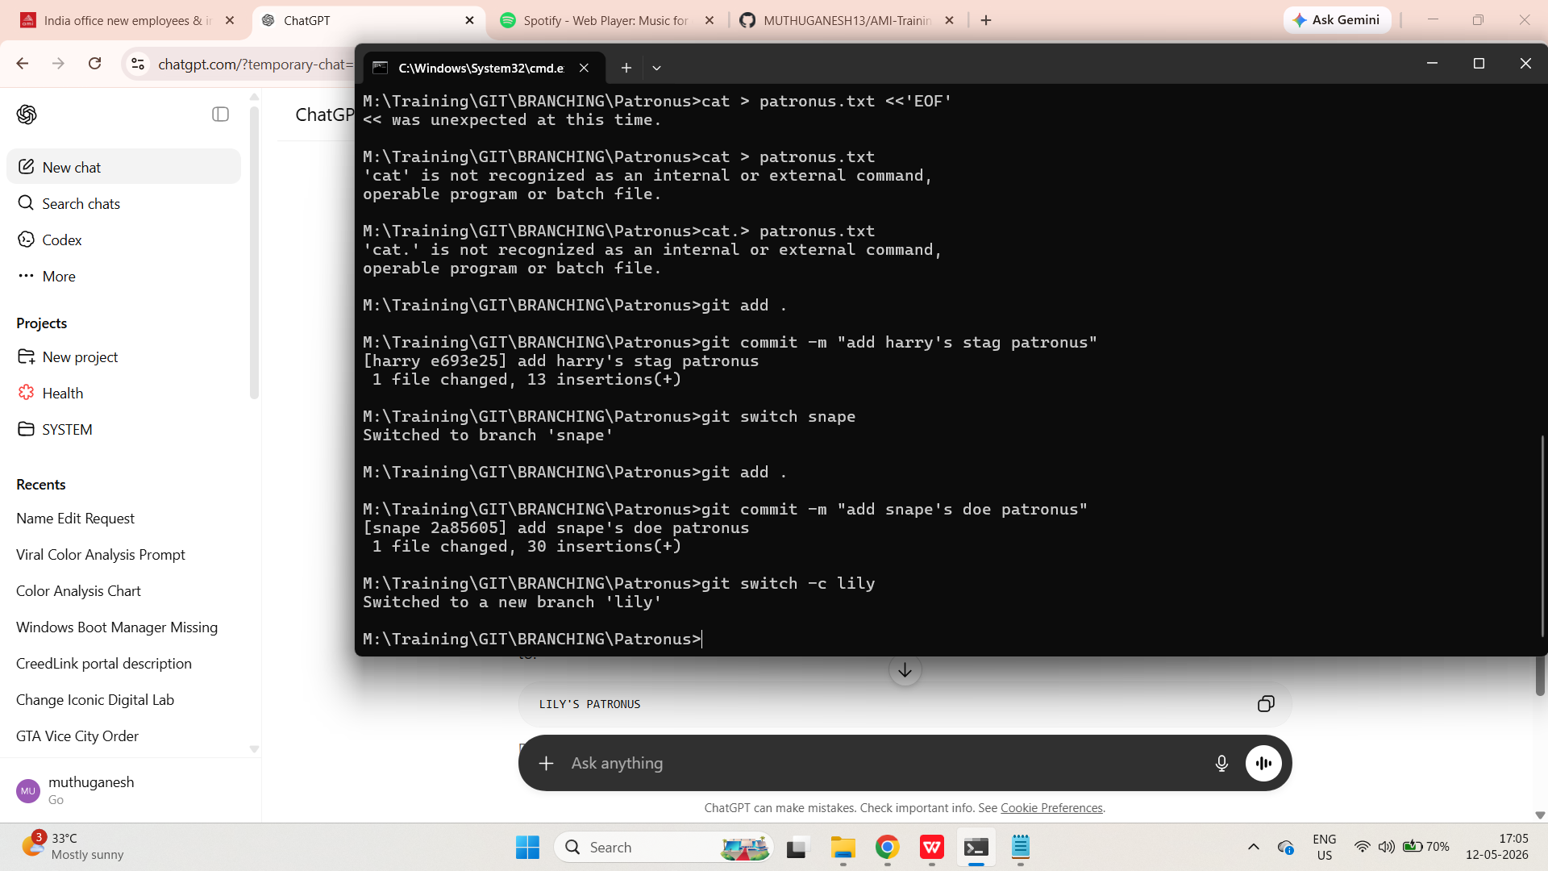
Move to the lily branch
ALREADY DONE IN SAME COMMENT ITSELF

Edit the patronus.txt file so that it says LILY'S PATRONUS at the top instead ofSNAPE'S PATRONUS
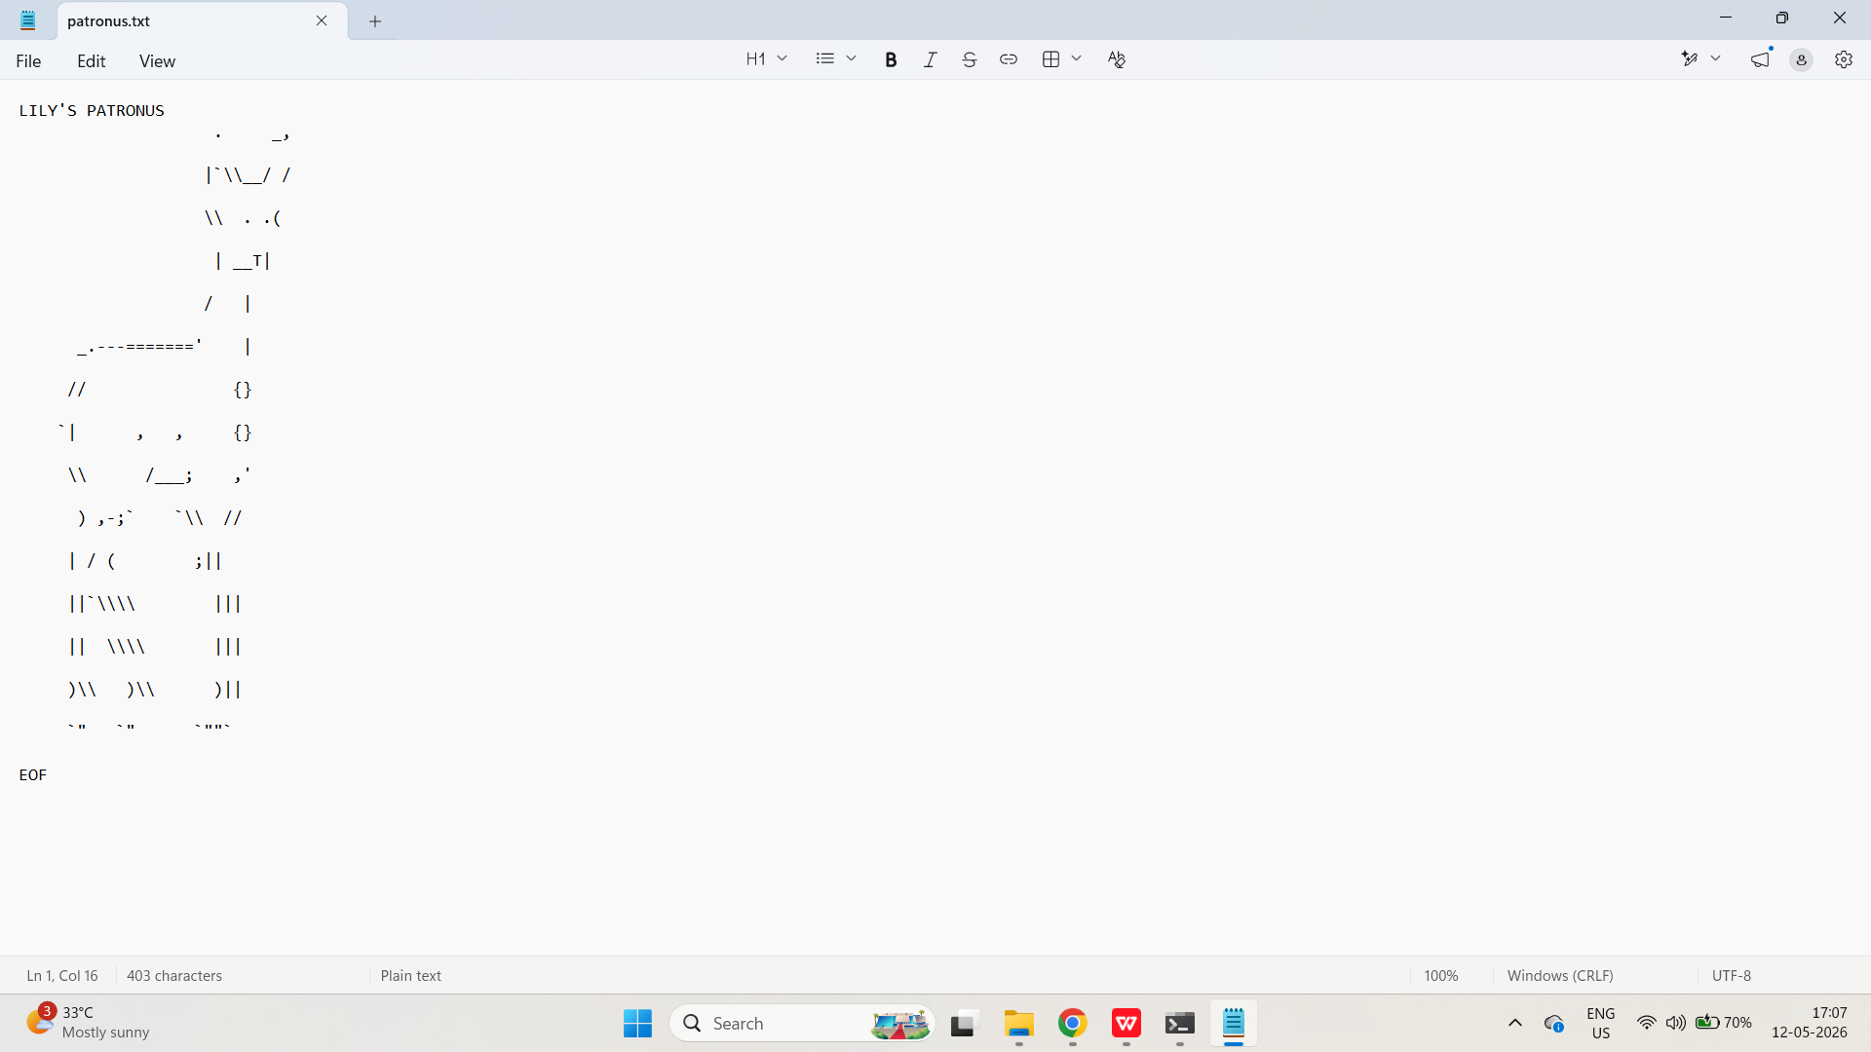
(leave the doe ascii-art alone)
Add and commit the change with the message "add lily's doe patronus"
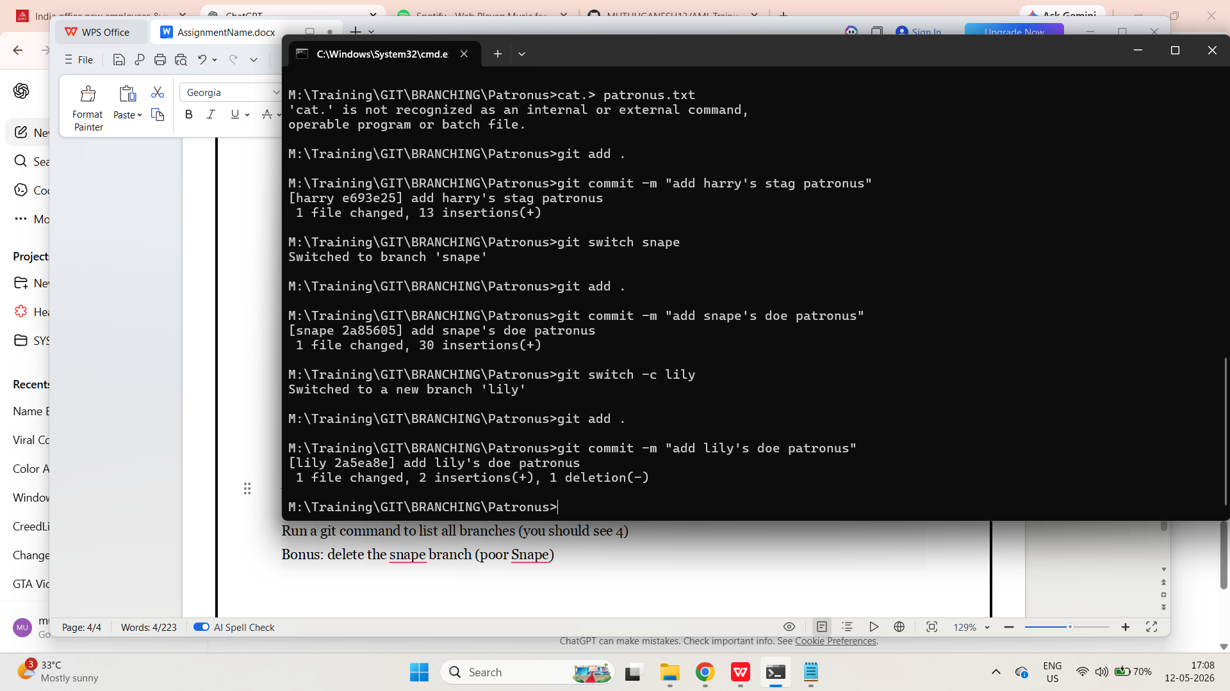
Run a git command to list all branches (you should see 4)
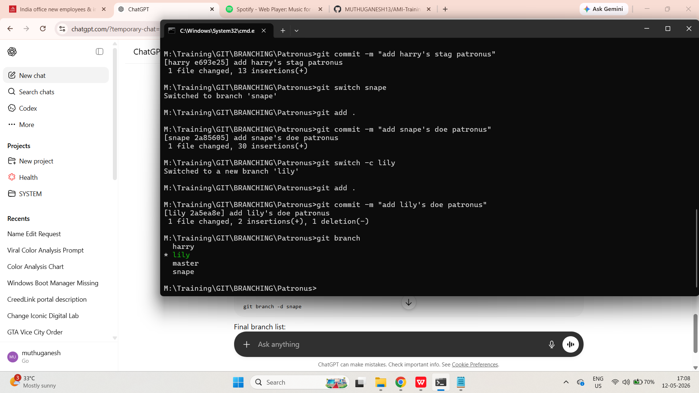
Bonus: delete the snape branch (poor Snape)
